SIMATS ENGINEERING (SAVEETHA SCHOOL OF ENGINEERING)
Department of Computer Science and Engineering
CO2 ASSESSMENT TOOL 2 – Architecture Design Assignment

Course Code: | CSA1007 | Course Title: | Software Engineering
CO Assessed: | CO2 | Assessment: | Assessment Tool 2 – Architecture Design Assignment
Weightage: | 20% | Total Marks: | 25
CO2 Statement: | Perform detailed requirements analysis, design scalable architectures, and prioritize features with a focus on cross-disciplinary skills
Student Name: | MEGALA.P | Reg. No.: | 192573019
Date: | 30/7/26 | Duration: | 60 minutes

Code of Conduct
I Megala.P(192573019) (Name / Reg No) certify that this submission is my original work and that I have adhered to the guidelines specified for this assessment. I understand that any violation of academic integrity rules will result in disciplinary action.
Signature of the Student: Megala.P
Annexure A – Architecture Design Assignment
Instructions to Students:
Each student will be assigned an individual software project problem statement. Based on the assigned problem, analyze the system requirements and design an appropriate software architecture by applying software engineering principles. Your submission should demonstrate your ability to select, justify, and evaluate a suitable architectural style.

Question
Based on your assigned problem statement, perform an Architecture Design Analysis and prepare an architecture design report by answering the following questions:

1. Analyze System Requirements
- Study the given problem statement and identify the system objectives.
- Analyze the functional and non-functional requirements that influence the software architecture.
- Identify key quality attributes such as scalability, maintainability, reliability, availability, performance, and security.

2. Select a Suitable Software Architecture
- Select an appropriate architectural style for the proposed system (e.g., Layered Architecture, Client-Server, MVC, Microservices, Event-Driven, Service-Oriented Architecture, Serverless, or Hybrid Architecture).
- Justify why the selected architecture is the most suitable for the given problem.

3. Draw the Software Architecture Diagram
- Design a clear architecture diagram illustrating the overall structure of the proposed system.
- Include all major layers/components, databases, external systems, APIs, and communication mechanisms.
- Use appropriate software architecture notations and labels.

4. Explain Components and Their Interactions
- Describe the purpose and responsibilities of each architectural component.
- Explain how the components communicate and exchange data.
- Illustrate the overall workflow of the system.

5. Discuss Quality Attributes
Evaluate how the proposed architecture addresses the following aspects:
- Scalability
- Security
- Performance
- Reliability
- Maintainability
- Availability

6. Justify Architectural Decisions
- Explain the rationale behind your architectural choices.
- Discuss the trade-offs considered while selecting the architecture.
- Explain how the chosen architecture supports future enhancements, system integration, and long-term maintainability.
Rubrics for Calculation
Evaluation Criteria | Excellent (4 Marks) | Good (3 Marks) | Satisfactory (2 Marks) | Needs Improvement (1 Mark)
System Requirement Analysis | Thoroughly analyzes the problem statement, accurately identifies functional and non-functional requirements, and clearly explains quality attributes influencing the architecture. | Analyzes most requirements with minor omissions or limited explanation. | Identifies only basic requirements with partial analysis. | Requirement analysis is incomplete, inaccurate, or lacks clarity.
Selection of Software Architecture | Selects the most appropriate architectural style with strong technical justification aligned to system requirements. | Selects a suitable architecture with reasonable justification. | Architecture is partially suitable with limited justification. | Inappropriate architecture selected or justification is missing.
Architecture Diagram and Component Design | Produces a clear, complete, and well-structured architecture diagram with all major components, interfaces, and interactions accurately represented. | Diagram is mostly complete with minor omissions or notation issues. | Diagram includes only essential components and lacks sufficient detail. | Diagram is incomplete, unclear, or technically incorrect.
Component Interaction and Quality Attribute Analysis | Clearly explains component responsibilities, interactions, and thoroughly discusses scalability, security, performance, reliability, maintainability, and availability. | Explains most components and quality attributes with minor gaps. | Provides limited explanation of interactions and addresses only some quality attributes. | Component interactions and quality attributes are poorly explained or missing.
Architectural Justification and Technical Presentation | Provides strong justification for architectural decisions, discusses trade-offs and future enhancements, and presents a well-organized, professional report. | Provides adequate justification with minor gaps; report is well organized. | Limited justification with minimal discussion of trade-offs or future scope; report needs improvement. | Justification is weak or absent; report lacks organization and technical clarity.

Criteria | Mark
System Requirement Analysis | /5
Selection of Software Architecture | /5
Architecture Diagram and Component Design | /5
Component Interaction and Quality Attribute Analysis | /5
Architectural Justification and Technical Presentation | /5
TOTAL | /5

Architecture Design Analysis Report
Factory Energy Monitoring and Machine Utilization Optimization System
NAME :MEGALA.P SLOT:D
REG NO:192573019 COURSE CODE: CSA1007

1. Analyze System Requirements
System Objectives
The proposed system aims to:
- Monitor real-time energy consumption of factory machines.
- Track machine utilization and operational efficiency.
- Detect abnormal energy usage and machine faults.
- Generate reports and analytics for management.
- Reduce operational costs by optimizing energy usage.
- Improve machine productivity through predictive monitoring.
Functional Requirements
- User login and authentication.
- Register and manage machines.
- Collect sensor data (energy, temperature, runtime).
- Display live monitoring dashboard.
- Generate alerts for excessive energy consumption.
- Calculate machine utilization percentage.
- Generate daily, weekly, and monthly reports.
- Store historical data for analysis.
- Admin can configure thresholds and alerts.
- Non-Functional Requirements
- High availability (24×7 monitoring)
- Real-time performance
- Scalability for adding new machines
- Secure communication
- Reliability of sensor data
- Easy maintenance
- Fast response time
Quality Attributes
Quality Attribute | Description
Scalability | Supports thousands of IoT devices
Reliability | Continuous monitoring without data loss
Performance | Real-time dashboard updates
Security | Authentication, authorization, encrypted communication
Maintainability | Independent services are easy to modify
Availability | Cloud deployment with backup services

2. Suitable Software Architecture
Selected Architecture
Microservices + Event-Driven Architecture (Hybrid)
Justification
This project requires:
- Real-time sensor data processing
- Independent monitoring modules
- Large number of machines
- High scalability
- Continuous event processing
Microservices allow each module to operate independently, while Event-Driven Architecture enables instant communication between sensors and services using message queues.
Therefore, a Hybrid Architecture (Microservices + Event-Driven) is the most suitable choice.

3. Software Architecture Diagram
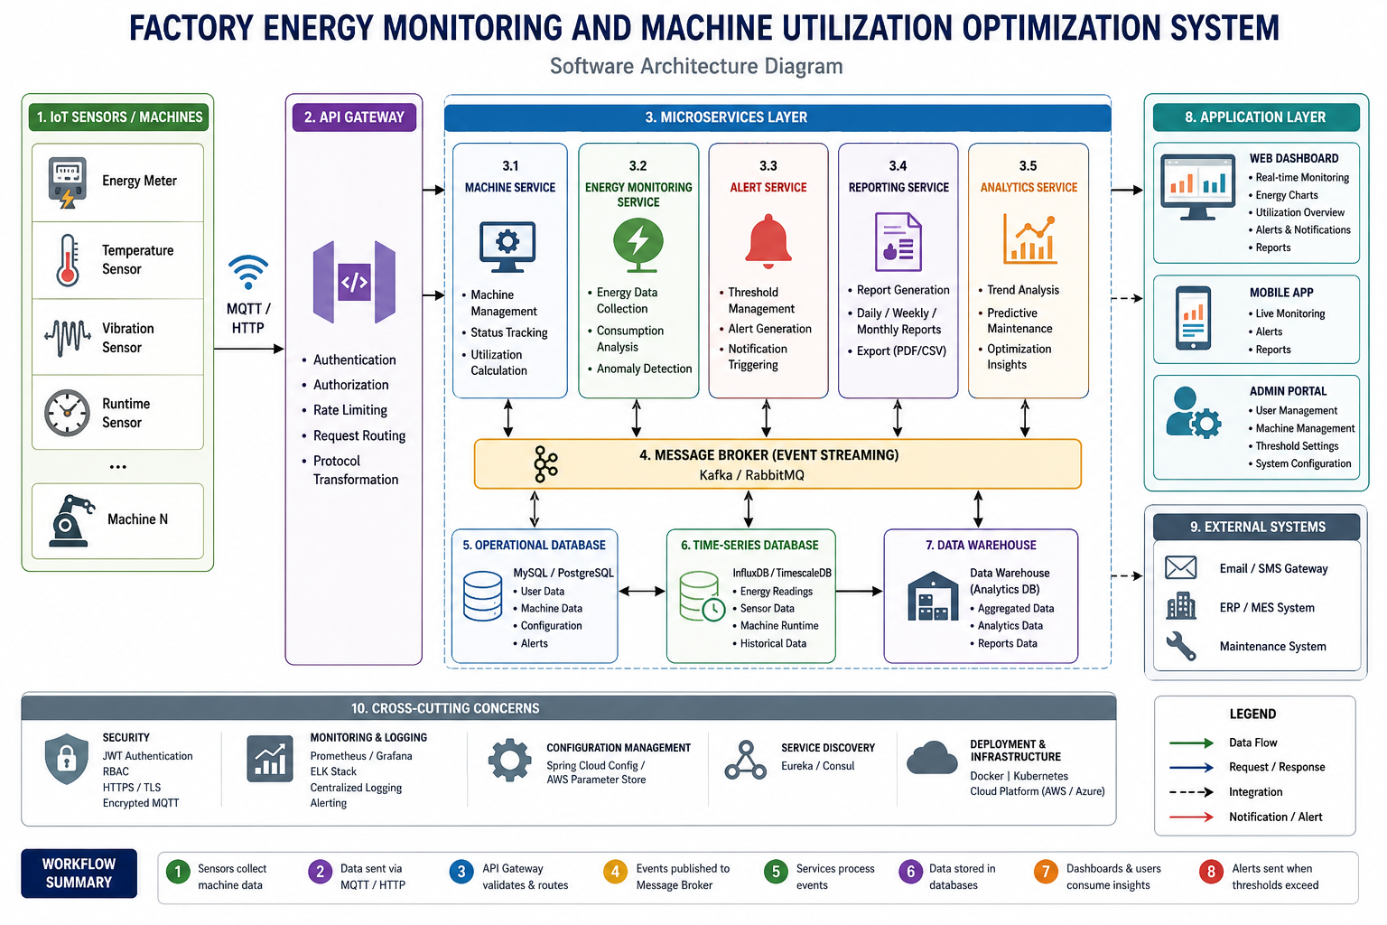

4. Components and Their Interactions
1. IoT Sensors
- Collect energy usage.
- Monitor machine runtime.
- Measure temperature and vibration.

2. API Gateway
- Receives all sensor requests.
- Routes requests to appropriate services.
- Performs authentication.

3. Machine Service
- Maintains machine information.
- Stores machine status.
- Calculates utilization.

4. Energy Monitoring Service
- Receives energy readings.
- Detects abnormal consumption.
- Stores historical energy data.

5. Alert Service
- Generates alerts.
- Sends SMS/Email notifications.
- Notifies maintenance teams.

6. Reporting Service
Creates:
- Daily reports
- Monthly reports
- Machine efficiency reports
- Energy consumption reports

7. Analytics Service
Performs:
- Trend analysis
- Predictive maintenance
- Energy optimization
- Machine utilization forecasting

8. Dashboard
Displays:
- Live machine status
- Energy graphs
- Utilization charts
- Alerts
- Reports

Workflow
- Sensors collect machine data.
- Data is transmitted through MQTT/HTTP.
- API Gateway authenticates requests.
- Message Broker distributes events.
- Energy Service analyzes consumption.
- Machine Service updates utilization.
- Analytics Service predicts failures.
- Alert Service sends notifications if thresholds are exceeded.
- Dashboard displays real-time information.

5. Quality Attribute Evaluation
Attribute | Implementation
Scalability | Independent microservices can scale individually.
Security | JWT authentication, HTTPS, encrypted MQTT communication, role-based access control.
Performance | Event-driven messaging enables low-latency processing.
Reliability | Message queues prevent data loss; replicated databases improve fault tolerance.
Maintainability | Services are loosely coupled and independently deployable.
Availability | Cloud deployment with load balancing, auto-scaling, and database replication ensures high uptime.

6. Justification of Architectural Decisions
Why Microservices?
- Independent deployment
- Easy maintenance
- Supports future expansion
- Better fault isolation
Why Event-Driven Architecture?
- Handles continuous sensor streams efficiently.
- Enables asynchronous communication.
- Provides faster alert generation.
Trade-offs
Advantage | Disadvantage
Highly scalable | More deployment complexity
Fault isolation | Higher infrastructure cost
Independent updates | Requires service orchestration
Fast event processing | More monitoring effort
Future Enhancements
- AI-based predictive maintenance
- Energy consumption forecasting
- Digital twin integration
- Machine learning optimization
- Cloud-native Kubernetes deployment
- Integration with ERP/MES systems

Conclusion
The Hybrid Microservices and Event-Driven Architecture is well suited for the Factory Energy Monitoring and Machine Utilization Optimization System. It supports real-time monitoring, efficient event processing, scalability, security, and long-term maintainability. The modular design allows future integration of advanced analytics and smart manufacturing technologies while ensuring reliable and high-performance operation.

